# Comprehensive Digital Marketing Project work

## Part 1: Brand study, Competitor Analysis & Buyer’s/Audience’s

**Persona**

###### COMPANY/TOPIC for project : AXIS BANK

* **Research Brand Identity:** Study the brand's mission, values, vision, and unique selling

propositions (USPs).

* 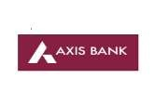 **Brand colours :** Marooon , white **Logo :**

**Misson/Values :**

Axis Bank's mission is to be the preferred financial solutions provider excelling in customer

delivery through insight, empowered employees and smart use of technology.

**USP :**

Axis Bank is one of the largest private sector financer in Indian agriculture

**Part 1: Brand study, Competitor Analysis &**

**Buyer’s/Audience’s Persona**

**COMPANY/TOPIC for project : AXIS BANK Brand Messaging :** Informative & Awareness



[https://www.instagram.com/p/CvFCJ_BLL_D/?igshid=NTc4MTI](https://www.instagram.com/p/CvFCJ_BLL_D/?igshid=NTc4MTIwNjQ2YQ%3D%3D)

[wNjQ2YQ==](https://www.instagram.com/p/CvFCJ_BLL_D/?igshid=NTc4MTIwNjQ2YQ%3D%3D)

**Tagline :** We are just the bank you need

### Part 1: Brand study, Competitor Analysis &

**Buyer’s/Audience’s Persona**

* + **Competitor Analysis:** Select three competitors operating in the same industry or

niche as the chosen brand, examine their USPs and online communication.

**Competitor 1:** ICICI BANK

<https://www.icicibank.com/>

**USP :** ICICI is the most efficient and tech Savvy bank in the Indian banking industry

**Online Communication :** Provided toll free number and chat box

**Competitor 2 :** HDFC BANK

<https://www.hdfcbank.com/>

**USP :** HDFC is one of the leading brands in the banking & financial services sector. HDFC SWOT analysis evaluates the brand by its strengths & weaknesses which are the internal factors along with opportunities & threats which are the external factors**.**

**Online Communication :** Provided official website URL and chat box

**Competitor 3:** IDFC FIRST BANK <https://www.idfcfirstbank.com/>

**USP** : At the heart of IDFC FIRST Bank has a simple belief – customer centricity. The brand's USP is its positioning and this is articulated in 3 simple words- ALWAYS YOU FIRST.

**Online Communication :** Provided contact number and email id

### Part 1: Brand study, Competitor Analysis & Buyer’s/Audience’s

* + - **Buyer's/Audience's Persona:** C**P**le**e**a**r**r**s**ly**o**de**n**fi**a**ne the target audience for the chosen

brand. Consider demographics, psychographics, behaviors, and interests.

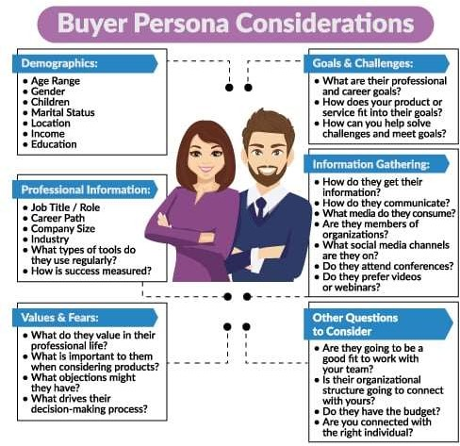**AXIS BANK**

**Demographics :**

Age Range: above 18

Gender : All

Children: not eligible (minor)

Marital status : Both (married/unmarried)

Location : All over INDIA

Income : 3,00,000

Education : 10+2

Information Gathering :

How do they get their information:

Community platforms , You tube ads , Facebook and Instagram ads.

Values / fears:

What do they value in their professional life :

Customer Centricity, Ethics, Transparency, Teamwork and

Ownership

### Part 2: SEO & Keyword Research

* **SEO Audit:** Do an SEO audit of the brands website
* **Keyword Research:** Define Research Objectives, Brainstorm Seed Keywords, Utilize

Keyword Research Tools (SEMrush or Moz Keyword Explorer),Analyze Competitor

Keywords, Long-tail Keyword Exploration (specific, longer phrases) that align with the

research objectives and have lower competition but higher conversion potential.

* **On page Optimization:** Meta Tag optimization & content optimization

Reflect on the process of conducting keyword research and the SEO recommendations

provided.

Document the challenges faced during the research and analysis phase, as well as the key insights gained from the keyword research process.

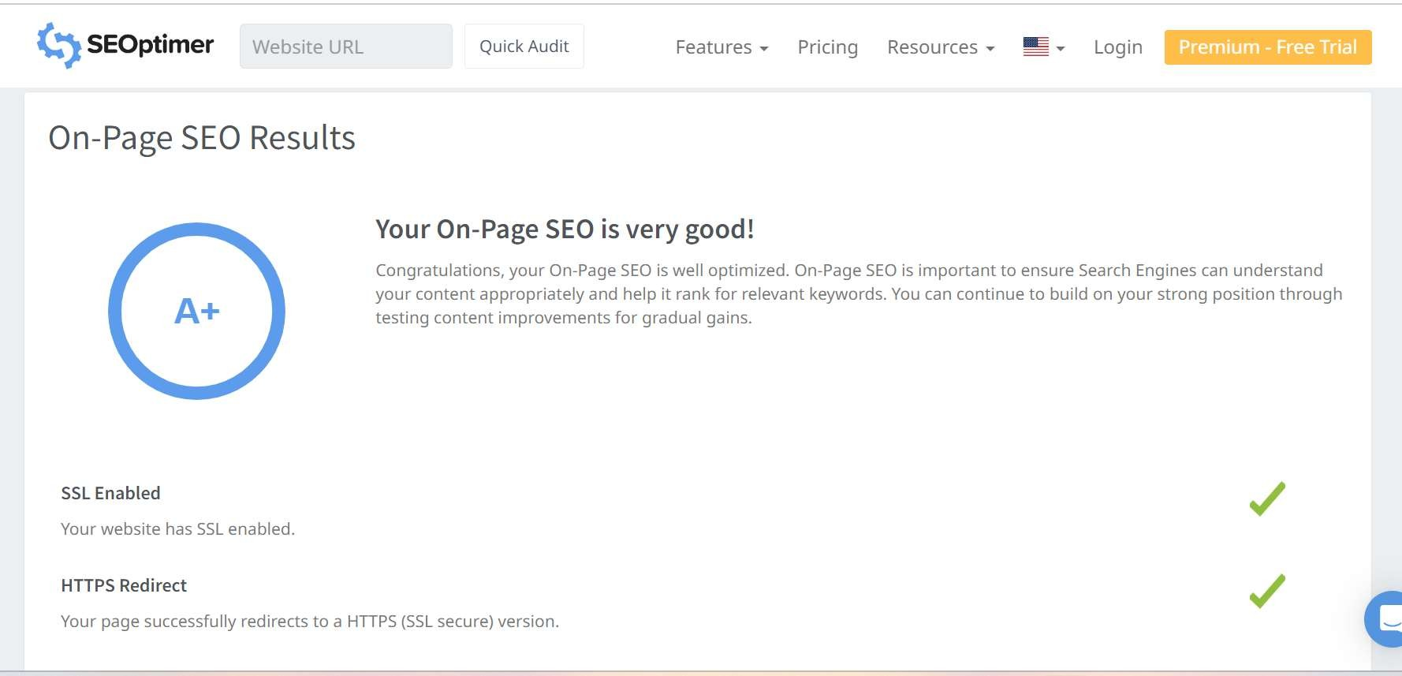**SEO Audit:** Do an SEO audit of the brands website

* + **SEO Audit:** Do an SEO audit of the brands website.

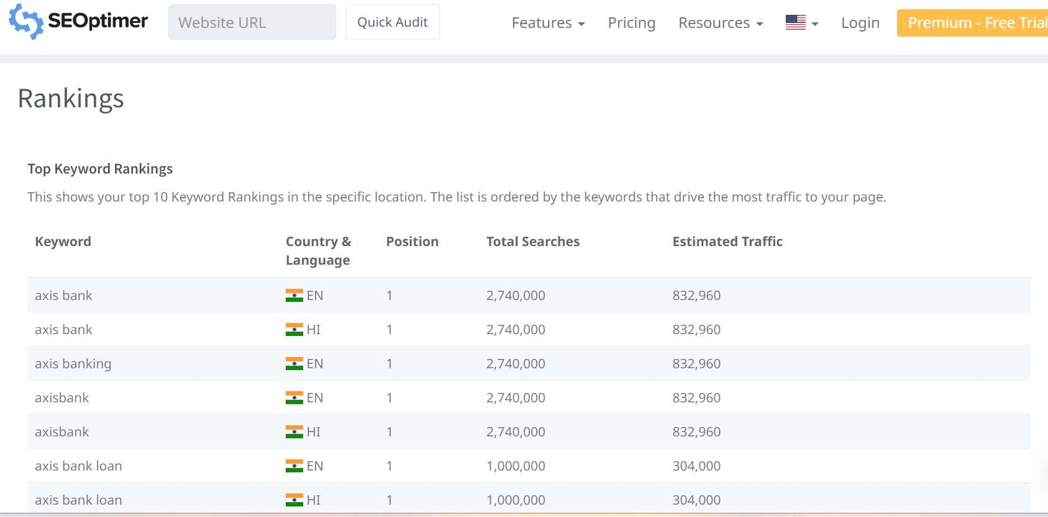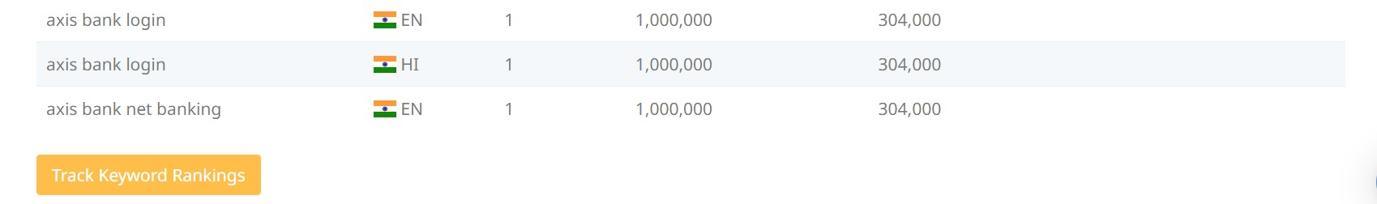

Keyword Research

keyword **:** LOAN

|  |  |  |  |  |  |
| --- | --- | --- | --- | --- | --- |
|  | **Keyword** | **Avg. monthly searches** | | **Competition** |  |
|  | mudra loan | 500000 | | Low |  |
|  | car loan | 50000 | | Low |  |
|  | kcc loan | 50000 | | Low |  |
| **Meta Tittle** | | | | | |
| Check the best loans for mudra,car and mudra loans | | | | | |
| **Meta Description** | | |  | | |
| Apply for low interest rate of car loan,kcc loan & mudra loan at our Axis Bank | | |  | | |

Keyword : Loan interest rate

|  |  |  |
| --- | --- | --- |
| **Keyword** | **Avg. monthly searches** | **Competition** |
| axis bank home loan | 50000 | Low |
| axis bank home loan interest rate | 50000 | Low |
| axis bank personal loan interest rate | 50000 | Low |

|  |  |  |  |
| --- | --- | --- | --- |
| Meta Title |  |  |  |
| Check the interest of personal & homeloan rate at our bank |  |  | Y |

|  |  |  |
| --- | --- | --- |
| Meta Description |  |  |
| Apply now to get more benefits for home and personal  loan at our axis bank |  |  |

**Keyword : calculator**

|  |  |  |
| --- | --- | --- |
| **Keyword** | **Avg. monthly searches** | **Competition** |
| savings account interest calculator | 5000 | Low |
| interest calculator savings | 5000 | Low |
| axis bank home loan calculator | 5000 | Low |

|  |  |  |
| --- | --- | --- |
| **Meta Tittle** |  | |
| Check your saving account,intrest & home loan calculator |  | |
| **Meta Description** | |  |
| Apply for more features for home loan and personal loan at our axis bank | |  |

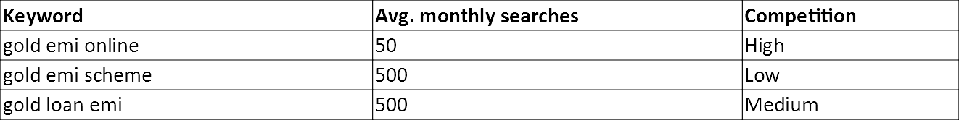Keyword : emi

Meta Tittle:

Explore new options like gold emi online,gold emi scheme,gold loan emi

Meta Description:

Check the interesting gold emi online, gold emi scheme,gold loan emi at Axis Bank

Keyword : Charges

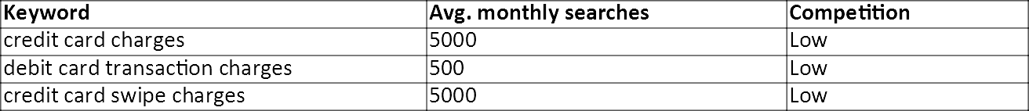

Meta Title:

Check the charges of Credit card,debit card & credit card swipe charges

Meta Description:

Apply feautured Loans like Home loan, Mudra Loan, Student Loan from AXIS bank

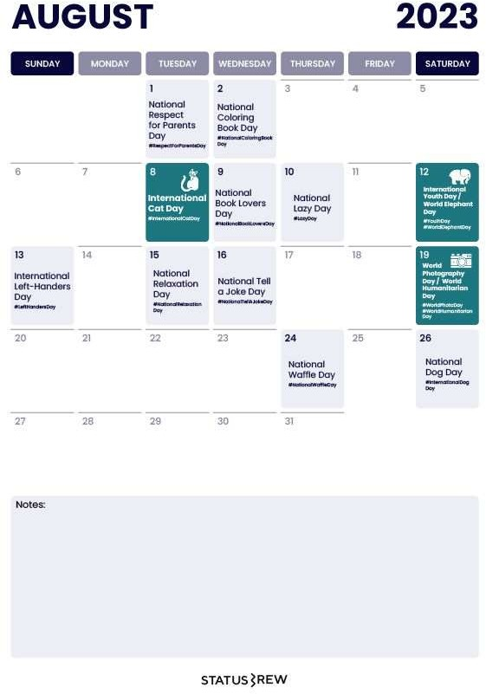**Part 3: Content Ideas and Marketing**

**Strategies**

* **Content Idea Generation & Strategy:** Create a content calendar for the remaining month of July by brainstorming content themes, exploring

various formats like blog posts, videos, infographics, podcasts, and interactive quizzes, and scheduling publication dates mainly on Facebook & Instagram.

And include the strategy, aim and the idea behind

these posts and story

Content Calendar Example (Try creating a

table for the month of July)

**Date :**5th August

##### Part 3: Content Ideas and Marketing Strategies

To make banking services more convenient for our customers . Implement a virtual ATM assistance customers can pre-select their transaction preferences, reducing the Implement a virtual ATM assistance customers can pre-select their transaction preferences, reducing the

**Date :**6th August

To excite customers about the convenience and efficiency of the bank's new digital services. Encouraging customers to use their banking transactions at online or digital banking.

**Date :**7th August

A clear information gives to customers about digital banking and also customers can easily use digital banking and we encourage customers to use digital banking features.It helps to easy banking transactions.

##### Part 3: Content Ideas and Marketing Strategies

* + Reflect on the content ideas and marketing strategies process, discussing the challenges

encountered and lessons learned.

Creating content ideas and devising effective marketing strategies is a dynamic process that involves continuous learning and adaptation. Throughout this journey, several challenges and valuable lessons can be encountered.

1. **Understanding the Audience**: One of the primary challenges is comprehending the target audience's preferences, needs, and pain points.
2. **Generating Unique Ideas**: Coming up with fresh and innovative content ideas can be difficult, especially in saturated markets.
3. **Consistency and Quality**: Maintaining a consistent flow of high-quality content can be demanding. Setting up an editorial calendar and adhering to a content creation schedule helps in maintaining quality and meeting deadlines.
4. **Content Promotion**: Even the best content may not gain traction without proper promotion. Crafting

effective marketing strategies to reach the target audience across various channels is crucial for success.

1. **Collaboration**: Collaborating with influencers or other brands can amplify the reach of content and

strengthen marketing efforts.

The content ideas and marketing strategies process is an iterative and learning-oriented journey

Part 4: Content Creation and Curation (Post creations, Designs/Video Editing, Ad Campaigns over

**Social Media and Email Ideation and Creation)**

**Post Creation:**

* + **Select Content Categories:** Identify three different content formats relevant to the chosen topic or industry. Research and Brainstorm: Research trending topics, industry news, or audience interests within each category. Brainstorm ideas for social media posts that align with each category. Do

note that 1 content format has to be video and additionally 3 stories/status are to be created.

Format 1 : Blog article Format 2 : Video Format 3 : Creative

Part 4: Content Creation and Curation (Post creations, Designs/Video Editing, Ad Campaigns over

**Social Media and Email Ideation and Creation)**

**Format 1 : Blog Article**

**Aim** : To make banking services more convenient for our customers .

**Date :** August 5th 2023

**Idea :** Implement a virtual ATM assistance customers can pre-select their transaction preferences, reducing the

. time spent on the actual ATM**.**

**Topic: Streamlining ATM Transactions with Virtual ATM Assistants**

Introduction

As technology continues to advance, businesses are looking for innovative ways to improve customer experiences and increase efficiency. One such advancement is the integration of virtual ATM assistants, which allow customers to pre-select their transaction preferences before arriving at the ATM..

Step 1: Understanding Customer Needs

Before developing the virtual ATM assistant, it's crucial to analyze your customers' needs and preferences. Conduct surveys, focus groups, or use data analytics to gather insights into the most common ATM transactions, security concerns, and any other relevant factors that impact customer experience.

options and additional security measures based on customer feedback and changing technological trends.

.

Step 2: Define Transaction Preferences

Ba**.** sed on the data collected in Step 1, determine the set of transaction preferences customers can pre-select.

Typical preferences may include:

1. Language selection
2. Transaction type (withdrawal, deposit, balance inquiry, funds transfer, etc.) 3.Preferred account (checking, savings, etc.)
3. Withdrawal amount limits
4. Receipt options (email, print, or none)

Step 3: Design User-Friendly Interface

Create an intuitive and user-friendly interface for customers to set their preferences. This interface can be a mobile app, a web portal, or integrated into the bank's existing mobile banking app. The design should be visually appealing and accessible to customers of all age groups.

Step 4: Security Measures

Security is of utmost importance when dealing with financial transactions. Implement multi-factor authentication, including password and biometric verification, to ensure the customer's identity is secure. Utilize encryption protocols to protect data transmitted between the virtual assistant and the ATM system. **Step 5: Backend Integration**

Integrate the virtual ATM assistant with the bank's ATM network and core banking system. This will require collaboration between the bank's IT team and the development team responsible for the virtual assistant. The integration should allow , perform security testing to validate .

**.**

Step 6: Testing and Quality Assurance

Thoroughly test the virtual ATM assistant to identify and resolve any bugs or issues. Conduct usability testing to ensure the interface is easy to navigate and understand. Additionally, perform security testing to validate the system's resistance to potential cyber threats.

Step 7: Pilot Program and Feedback

Before a full-scale launch, run a pilot program with a small group of customers to gather feedback. Encourage users to share their experiences and provide suggestions for improvement. Use this feedback to make necessary adjustments and enhancements to the virtual assistant system.

Step 8: Launch and Marketing

With all the necessary refinements in place, launch the virtual ATM assistant to the broader customer base. Conduct marketing campaigns to raise awareness about the new feature and its benefits. Highlight how the virtual assistant saves time, enhances security, and improves overall ATM transactions.

Step 9: Continuous Improvement

The launch of the virtual ATM assistant is not the end; it's just the beginning. Continuously monitor its

performance, collect user data, and seek ways to enhance the system further. Incorporate new transaction

**Part 4: Content Creation and Curation (Post creations, Designs/Video Editing, Ad Campaigns**

**over Social Media and Email Ideation and Creation)**

**Format 2 : VIDEO**

**Aim :** To excite customers about the convenience

and efficiency of the bank's new digital services

**Date :** August 6th 2023

**Idea:** Encouraging customers to use their banking

transactions at online or digital banking.

Part 4: Content Creation and Curation (Post creations, Designs/Video Editing, Ad Campaigns

**over Social Media and Email Ideation and Creation)**

**Format 3 : Creative**

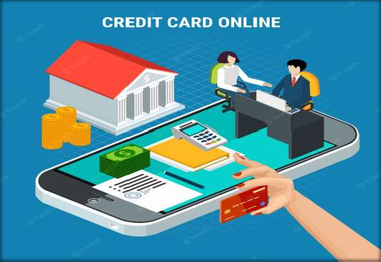

**Aim :** To create a poster on Digital banking

**Date :** August 7th 2023

**Idea :** A clear information gives to customers

about digital banking with a Poster

**Topic :** Poster

Part 4: Content Creation and Curation (Post creations, Designs/Video Editing, Ad Campaigns over

**Social Media and Email Ideation and Creation)**

# Instagram Story

Utilize the Stories feature on Instagram for three consecutive days. Share behind-the-scenes glimpses, polls, quizzes, or sneak peeks etc to encourage audience participation. Once uploaded use the story highlight feature on Instagram and save the 3 story with an appropriate name for each.

**Note:**

Once done monitor the performance of the posts and Stories using the insight tool and analyze the engagement metrics (likes, comments, shares, impressions, etc.). Based on the analysis, mention the strategies and areas for improvement.

Part 4: Content Creation and Curation (Post creations, Designs/Video Editing, Ad Campaigns over

**Social Media and Email Ideation and Creation)**

# Instagram Story

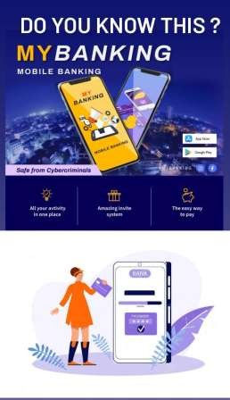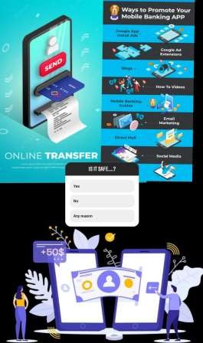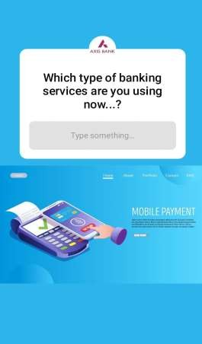

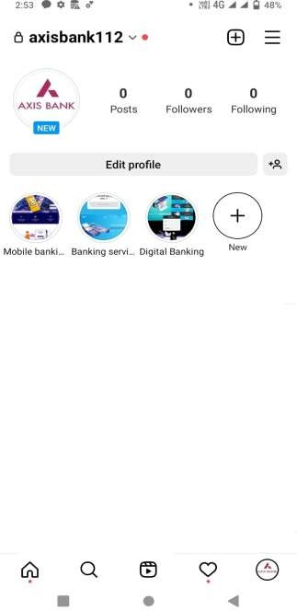**.**

Part 4: Content Creation and Curation (Post creations, Designs/Video Editing, Ad Campaigns over

**Social Media and Email Ideation and Creation)**

# Designs/Video Editing

* Design Tools Familiarization (use Canva for creating visually appealing graphics)
* **Video Creation:** Utilize VN or any video editor of your choice to create videos related to the

chosen topic.

**Part 4: Content Creation and Curation (Post creations, Designs/Video Editing, Ad Campaigns over**

**Social Media and Email Ideation and Creation)**

**Social Media Ad Campaigns**

**Ad Campaigns over Social Media:**

Come up with 3 ad campaigns each covering one of the mentioned goals: brand awareness,

driving website traffic, or generating leads

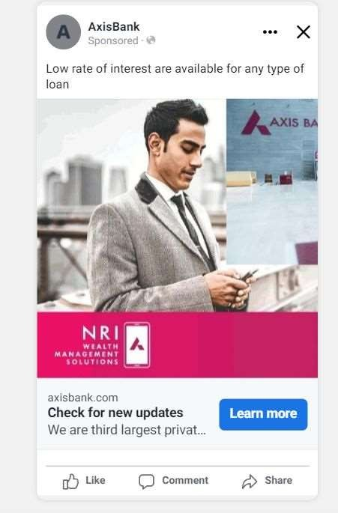

**Brand awareness :**

**Targeting :** Location: India, Gender: All,

interest : Debit card and credit card , loans.

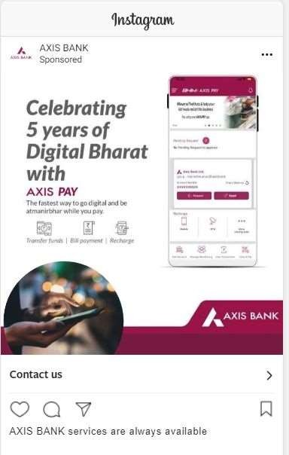

#### Driving website traffic:

**Targeting** : Location: India, Gender: All,

interest : Debit card and credit card , loans.



#### Generating leads :

**Targeting** : Location: India, Gender: All,

interest : Debit card and credit card , loans.

Part 4: Content Creation and Curation (Post creations, Designs/Video Editing, Ad Campaigns over

**Social Media and Email Ideation and Creation)**

**For every campaign clearly define:**

* + **Advertising Goals:** increasing brand awareness, driving website traffic, or generating leads.
  + **Audience Targeting:** Define the target audience for the ad campaigns based on demographics, interests, and behavior.
  + **Ad Creation:** Create visually appealing ad creatives, compelling ad copy and

relevant call-to-action.

Part 4: Content Creation and Curation (Post creations, Designs/Video Editing, Ad Campaigns over

**Social Media and Email Ideation and Creation)**

## Email Ad Campaigns

**Ad Campaigns for email marketing:**

Come up with 2 email ad campaigns with the mentioned goals: brand awareness & generating

leads

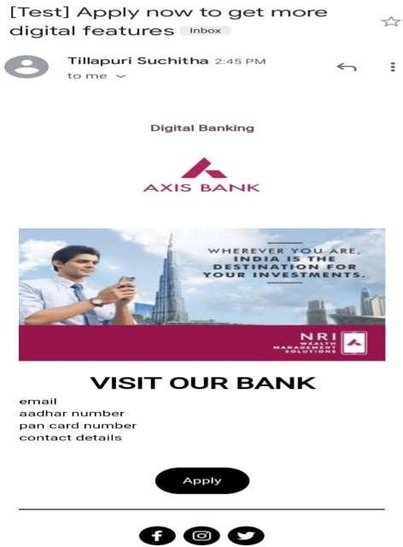

## Email Ad Campaign 1 - Brand Awareness

(insert emailer image)

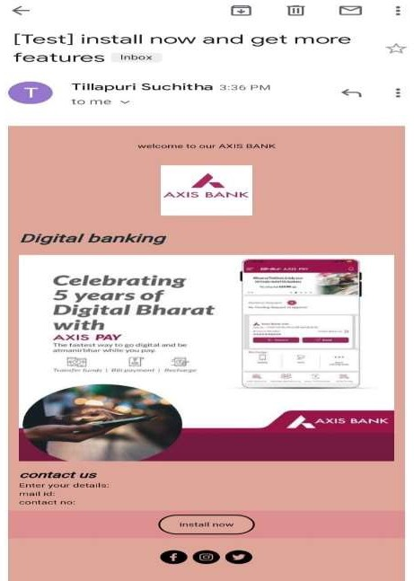

## Email Ad Campaign 2 - Lead Generation

(insert emailer image)

Part 4: Content Creation and Curation (Post creations, Designs/Video

**Editing, Ad Campaigns over Social Media and Email Ideation and Creation)**

* + Reflect on the content ideas and marketing strategies process, discussing the challenges

encountered and lessons learned.

* 1. **Know our Audience:** Understanding the target audience's interests, pain points, and preferences is fundamental in

creating relevant and engaging content.

* 1. **Visual Appeal:** Eye-catching visuals, well-designed graphics, and professionally edited videos can significantly enhance the impact of content and ad campaigns.
  2. **Consistency is Key:** Maintaining a consistent tone, style, and frequency of content across platforms helps reinforce

brand identity and improves audience recall.

* 1. **A/B Testing:** Regularly conducting A/B + tests for ad campaigns and email subject lines allows for data-driven

optimization and better results.

* 1. **Engage with the Audience**: Responding to comments, messages, and feedback from the audience fosters a sense of community and builds trust.
  2. **Long-Term Approach:** Content creation and marketing are not one-time endeavors. A long-term, strategic

approach is necessary to build brand awareness and achieve sustainable growth.

In conclusion, content creation and curation, along with thoughtful design, video editing, and well- executed ad campaigns, play a pivotal role in a successful marketing strategy. By understanding the challenges and incorporating the lessons learned, businesses can create compelling content that resonates with their target audience and drives results